Geologic Cross-Section Lab

The image below is an example of a geologic cross-section that can be used to determine the relative ages of geologic strata. Examine the cross section and answer the questions that follow.

1. Stratum 2 is a metamorphic rock. Strata X, Y, and Z are igneous rocks. All others are sedimentary rocks. Strata X, Y, and Z are all younger than Stratum 2. Which geologic principle explains this relative dating relationship?

Cross cutting relative principle

2. Strata 6 through 10 are now all tilted and folded, but they were not always this shape. What shape were they when they were deposited?

Flat layers

3. Which geologic principle explains the shape you selected in Number 2?

Principle of original horizontality

4. For each of the following pairs of strata, select the one that is older.

a) 2 or 6 = 2 b) 8 or 9 = 8 c) 10 or 14 = 10 d) Z or 2 = 2

e) Z or 6 = 6 f) Z or 12 = 12 g) Z or 19 = Z h) X or 2 = 2

i) X or 8 = X j) X or 6 = 6 k) Y or 2 = 2 l) Y or 6 = Y

The image below is a cross-section of an area in northern New Mexico where two dikes cut across numerous sedimentary rock formations. The dikes are composed of igneous rocks that contain a very small but significant amount of radioactive isotope X.

5. Use your knowledge of relative dating and the principles of geologic to place each of the following geologic units and events in order from oldest (Event 1) to youngest (Event

Deposition of Beds 1 through 4
Deposition of Beds 10 through 13
Deposition of Beds 5 through 9
Erosion Event 1
Erosion Event 2
Erosion Event 3
Formation of Schist
Intrusion of Dike A
Intrusion of Dike B
Uplift and Tilting of Beds 5 through 9
Uplift and Tilting/Folding of Schist and Beds 1-4

Order the 12 events here:

- Formation of Schist
- Deposition of Beds 1 through 4
- Uplift and Tilting/Folding of Schist and Beds 1-4
- Intrusion of Dike A
- Erosion Event 1
- Deposition of Beds 5 through 9
- Uplift and Tilting of Beds 5 through 9
- Intrusion of Dike B
- Erosion Event 2
- Deposition of Beds 10 through 13
- Erosion Event 3

The image below is a radioactive decay curve for the radioactive isotope X present in the schist and in dikes A and B. The x-axis is the age of the isotope in millions of years and the y-axis is the percentage of parent isotope X remaining. Use this decay curve to answer the following questions about the geologic cross-section you just analyzed.

6. The date of metamorphism of the schist is 436.9million years ago.
From the curve isotope X takes 200 million years to reach 50 percent hence half-isotope X= 200 million years
Schist contains 22 percent of isotope X, the metamorphosis date of Schist is equivalent to the time X was 100 percent using the formula
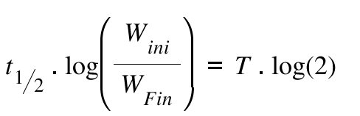
Where, t_{1/2} = Half-life of the isotope;
T = Time taken for the specific decay;
W_{ini} = Initial amount of the radioactive isotope;
W_{fin} = Final amount of the radioactive isotope
We can calculate for T
200*log (100/22) =131.515/log (2) =436.88

7. The date of the intrusion of Dike A is 347 million years ago.
Date of intrusion dike A, amount of isotope X in A =30 percent
At the time of dike A intrusion the X isotope content was 100 percent Time taken equals
200*log (100/30) =104.575/log (2) =347
8. The date of the intrusion of Dike B is 53 million years ago.
Date of intrusion dike B, amount of isotope X in B =83 percent
At the time of dike B intrusion the X isotope content was 100 percent Time taken equals
200*log (100/83) =16.184/log (2) =53

9. Based on the radioactive decay curve, the half-life of radioactive isotope X is 200 million years.

Because of the Principle of Included Fragments we cannot use numerical dating to determine the ages of the sedimentary rocks in the geologic cross-section. However, we can bracket the ages of these rocks using relative dating and the known ages of those rocks we can radiometrically date. Use the following geologic time scale to answer the last three questions regarding the ages of the sedimentary rocks in the geologic cross-section:

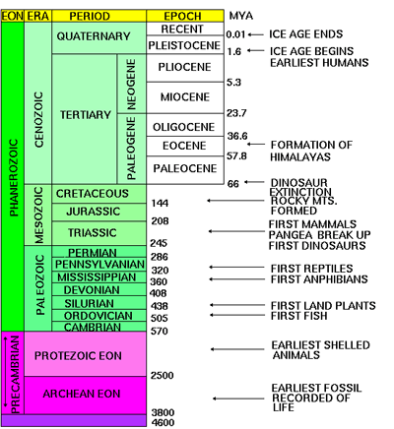

10. Over which geologic time periods did Beds 1 through 4 form?

Devonian-Permian

11. Over which geologic time periods did Beds 5 through 9 form?

Mississipian-Paleogenic

12. Bed 10 could not be any older than the Paleogenic period.

